# Question 01

## Code

clc

clear all

x=[-2:0.5:2]

part_a=(x+x.*sqrt(x+3)).*(1+2*x.^2)-x.^3

w=[15 25 35 40 55 60]

part_b=(4.*sind(w) + 6 )./(cosd(w).^2 .* sind(w)).^2

## Output

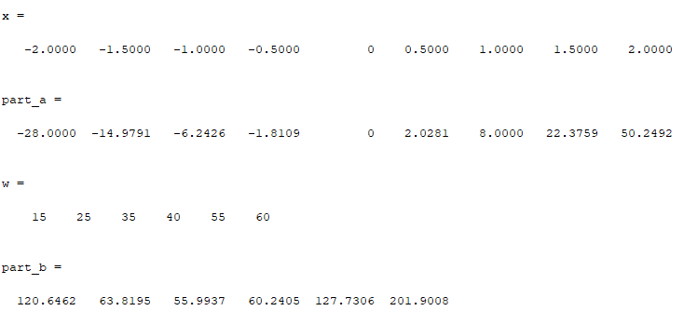

# Question 02

## Code

clc

clear all

v=[-5.6 11 -14]

part_a=sqrt(sum([v(1).^2 ,v(2).^2 ,v(3).^2]))

v1=[3.2 -6.8 9]

v2=[-4 2 7]

part_b=acosd((v1(1)*v2(1)+v1(2)*v2(2)+v1(3)*v2(3))/(sqrt(sum([v1(1).^2 ,v1(2).^2 ,v1(3).^2])) *sqrt(sum([v2(1).^2 ,v2(2).^2 ,v2(3).^2]))))

## Output

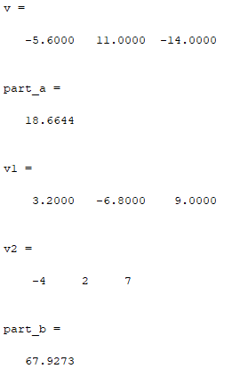

# Question 03

## Code

clc

clear all

x=[1:2:7]

part_a=3.*x

part_b=x.^2

part_c=x./x

part_d=[x(1)+5,x(2)+3,x(3)+1,x(4)-1]

## Output

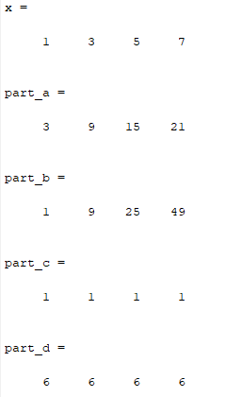

# Question 04

## Code

clc

clear all

v1=[2.5 8 -5]

v2=[-1 6 3]

angle_=asind(dot(cross(v1,v2),cross(v1,v2))/(dot(v1,v1)*dot(v2,v2)))

## Output

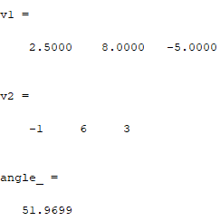

# Question 05

## Code

clc

clear all

A=[5 -3 7 ; 1 0 -6; -4 8 9]

B=[3 2 -1 ;6 8 -7; 4 4 0]

C=[-9 8 3 ; 1 7 -5; 3 3 6]

Part_a_1=5*(B+C)

Part_a_2=5*B+5*C

part_b_left=inv((B*C))

part_b_right=inv(B)*inv(C)

part_C_left=(A+B)'

part_C_right=A'+B'

## Output

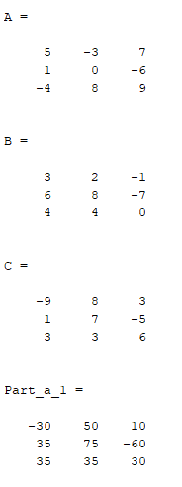

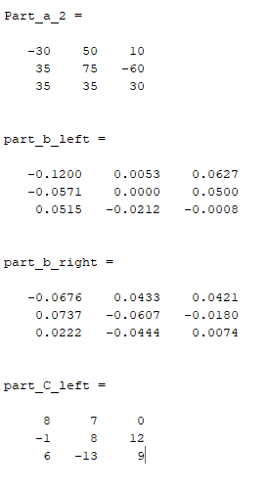

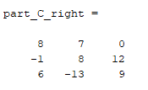

# Question 06

## Code

clc

clear all

A=[2 -4 5 -3.5 1.8 4;-1.5 3 4 -1 -2 5;5 1 -6 3 -2 2;

1.2 -2 3 4 -1 4; 4 1 -2 -3 -4 1.5;2 1 -1 4 -2 -4]

B=[52.52;-21.1;-27.6;9.16;-17.9;-16.2]

sol=inv(A)*B;

u=sol(1)

v=sol(2)

w=sol(3)

x=sol(4)

y=sol(5)

z=sol(6)

## Output

